- \Operation\Infeed conveyor\Vials infeed (Page 1 of 2)
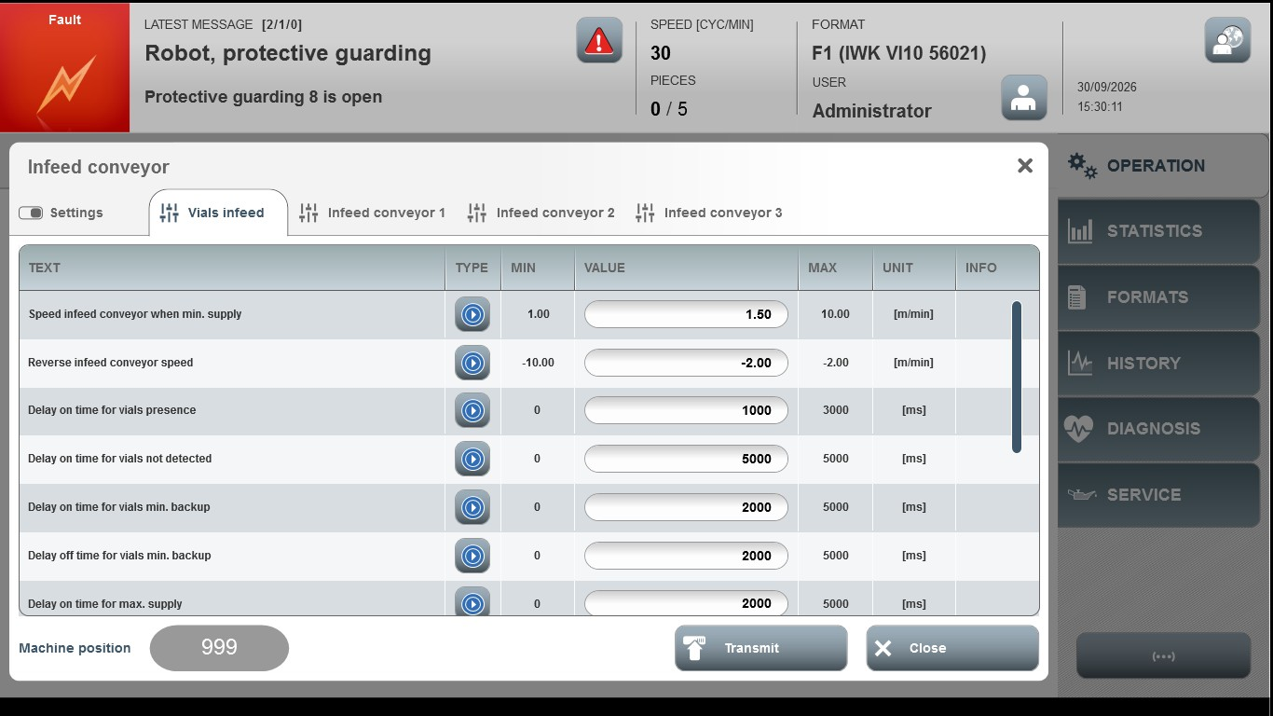
Acceptance criterion | Limits | Pass / Fail: Dev-No. | Date | Initials
Screen matches screenshot | N / A
Speed Infeed Conveyor When Min. Supply | 1.00...10.00
Reverse Infeed Conveyor Speed | -10.00...-2.00
Delay on time for product presence | 0 … 3000
Delay on time for product not detected | 0 … 5000
Delay on time for product min. backup | 0 … 5000
Delay off time for product min. backup | 0 … 5000
Delay on time for max. backup | 0 … 5000

- \Operation\Infeed conveyor\Vials infeed (Page 2 of 2)
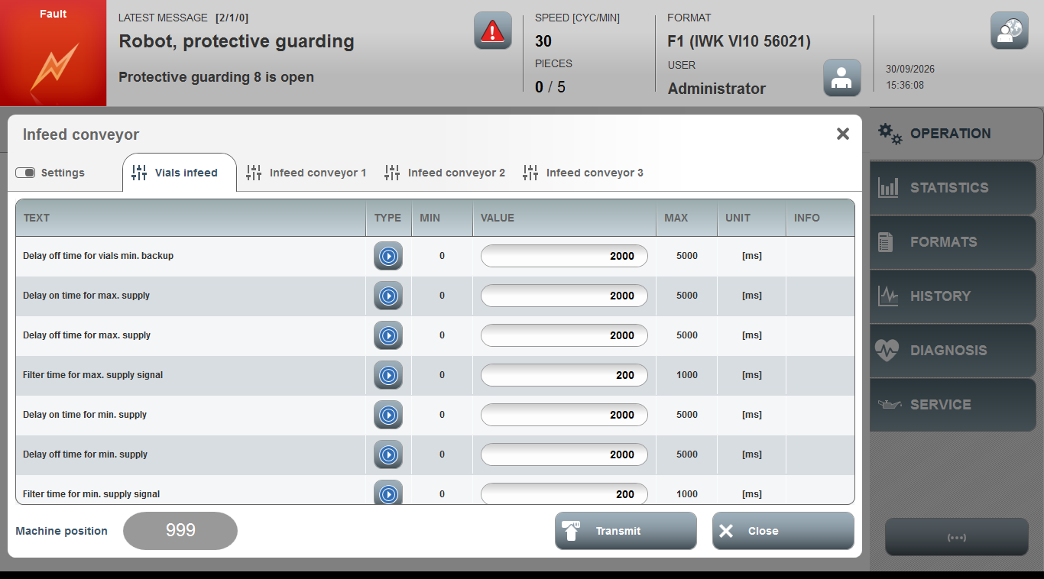
Acceptance criterion | Limits | Pass / Fail: Dev-No. | Date | Initials
Screen matches screenshot | N / A
Delay off time for product max. backup | 0 … 3000
Filter time for max backup sig-nal | 0 … 1000
Delay On Time for Min. Supply | 0 … 5000
Delay Off Time for Min. Supply | 0 … 5000
Filter Time for Min. Supply Signal | 0 … 1000

